Seneca Healthcare Congratulates Skilled Nursing Staff

Date: April 28, 2022
For: Immediate Distribution

Seneca Healthcare District would like to congratulate our Skilled Nursing Department and Staff for receiving a five-star rating from Care Compare. Please join the Seneca Team in recognizing this achievement and thanking our staff members for their hard work that has resulted in an amazing rating.

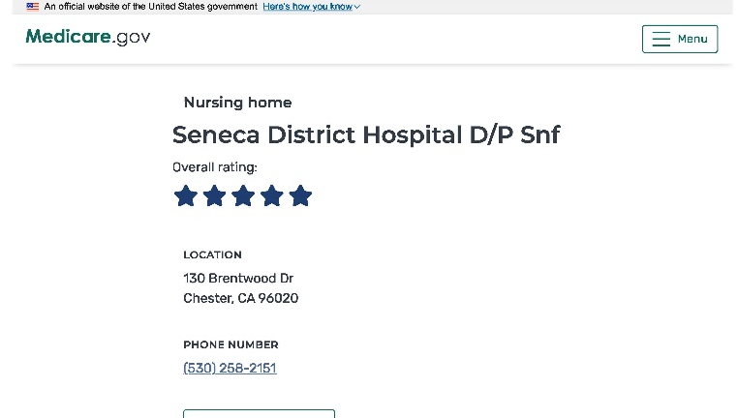
The Five-Star Quality Rating System was created by Centers for Medicare and Medicaid Services (CMS) to help consumers, their families, and caregivers compare nursing homes more easily, and to help identify areas where individuals may want to ask questions. The Nursing Home Care Compare website features a quality rating system that gives each nursing home a rating between 1 and 5 stars. Nursing homes with 5 stars are considered to have a higher, above average quality.

Check out the Care Compare website at www.medicare.gov/care-compare/details/nursing-home/555022?city=Chester&state=CA&zipcode=96020, to view Seneca’s rating and find out more information.

Congratulations once again to the Skilled Nursing Staff at Seneca Healthcare District, keep up the good work!

